‘trace route’
- To start a trace, go to Start→Run→cmd (or Start→Run→command), then press OK to open a command prompt window,
and type:

tracert - this will display the command options fro ‘tracert’

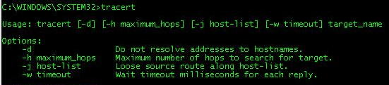s
*

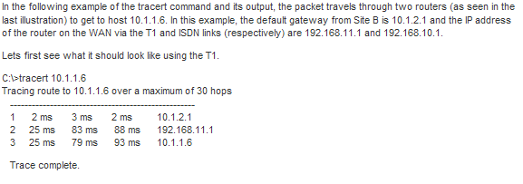
*
You should be able to see any network pathways (‘hops) that are taking a long time to complete.
*
You may need to specify the maximum number of hops that you want to allow the trace to examine.

